Introduction
This document describes a basic interactive graphical user interface (GUI) application built with Java Swing for the PROG209 Event Driven Programming module. The application uses a JFrame as the main window, a JPanel as a container, a JLabel to display a welcome message and an ImageIcon to display the application icon. It also demonstrates two important object-oriented concepts: inheritance and constructors.
To make the program interactive, two buttons were added. One button changes the text of the JLabel and the other changes the background colour of the JPanel. A colourful gradient design was used so that the application looks modern and attractive.

2. Objectives
- Create a GUI application using Java Swing with a JFrame, JLabel and JPanel.
- Apply inheritance and constructors in the program.
- Use ImageIcon to display an own application icon.
- Design a wireframe of the interface using Figma before coding.
- Add functionality to change the JLabel text and the JPanel background.
- Store the project on GitHub with a clear README file.
3. Tools Used
- Java Development Kit (JDK) and the Java Swing library (javax.swing and java.awt).
- IntelliJ IDEA or VS Code as the code editor.
- Figma for the wireframe design.
- Git and GitHub for version control and submission.

4. Wireframe Design
Before writing any code, a wireframe of the 800 x 800 pixel window was created in Figma. It shows the position of every component: the JFrame with its title bar, the JPanel that fills the window, the ImageIcon in the centre, the JLabel with the welcome message below it, and two buttons at the bottom. The legend on the right of the wireframe explains each component.
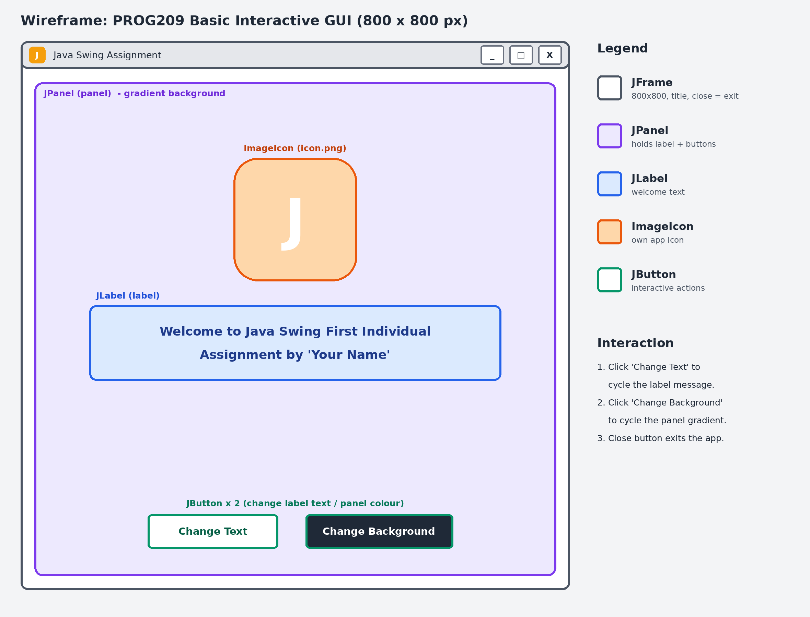
Figure 1: Wireframe of the application

5. Application Icon
A custom icon was designed for the application: an orange-to-amber gradient rounded square with a white letter “J” for Java. It is saved as icon.png and loaded with ImageIcon. The same icon is used as the window (title bar) icon and is shown above the welcome text.

Figure 2: Application icon (icon.png)

6. Implementation

6.1 JFrame
The JFrame variable named frame is created and instantiated inside the SwingAssignment class. Its title is set to “Java Swing Assignment”, its size to 800 x 800 pixels, and setDefaultCloseOperation(JFrame.EXIT_ON_CLOSE) makes sure that the application closes when the close button is clicked. The frame is centred on the screen with setLocationRelativeTo(null).

6.2 JPanel
The JPanel variable named panel is created and instantiated. It is an object of the class GradientPanel, which is a subclass of JPanel. The panel uses a BorderLayout: the label is placed in the centre and the row of buttons at the bottom. The panel is added to the frame.

6.3 JLabel
The JLabel variable named label is created with the text “Welcome to Java Swing First Individual Assignment by ‘Your name’” together with the icon. The text is white, bold, Tahoma size 28 and centred below the icon. The label is added to the panel.

6.4 ImageIcon
The method loadIcon() creates an ImageIcon from the file icon.png and scales it to the size needed. The icon is used for the window with frame.setIconImage() and for the label. If the file cannot be found, the program draws the same icon in code so that the application still runs.

6.5 Inheritance
Inheritance is shown by the nested class GradientPanel, which extends JPanel. It inherits all the behaviour of a normal JPanel and overrides the paintComponent() method to paint a vertical colour gradient as the background. The method setColors() lets the program change the two gradient colours and repaint the panel.

6.6 Constructors
Two constructors are used. The constructor of GradientPanel receives the top and bottom colours and stores them in its fields. The constructor SwingAssignment() creates and configures the frame, panel, label and buttons, so the whole GUI is built as soon as an object of the class is created in main().

6.7 Additional functionality
The “Change Text” button uses an ActionListener to move to the next message in an array and update the label with setText(). The “Change Background” button moves to the next colour theme and calls panel.setColors(), which changes the background colour of the JPanel. Each click gives immediate visual feedback, which is the main idea of event-driven programming.

7. Source Code
The complete source code of SwingAssignment.java is shown below.
import javax.swing.*;
import java.awt.*;
import java.awt.event.ActionEvent;
import java.awt.image.BufferedImage;

/**
* PROG209 - Event Driven Programming
* Assignment: Basic Interactive GUI (Java Swing)
*
* Demonstrates: JFrame, JPanel, JLabel, ImageIcon,
* inheritance (GradientPanel extends JPanel) and constructors.
*/
public class SwingAssignment {

// ====== CHANGE THIS TO YOUR NAME ======
private static final String STUDENT_NAME = "Your Name";

// ====== Required components (names as per the brief) ======
private JFrame frame;
private GradientPanel panel;
private JLabel label;

// ====== Data for the extra functionality ======
private final String[] messages = {
"Welcome to Java Swing First Individual Assignment by '" + STUDENT_NAME + "'",
"Event Driven Programming is fun!",
"Java Swing makes desktop apps easy",
"PROG209 - Limkokwing University, Sierra Leone"
};

// Each theme = {top colour, bottom colour}
private final Color[][] themes = {
{new Color(0x6A11CB), new Color(0x2575FC)}, // purple -> blue
{new Color(0xFF512F), new Color(0xDD2476)}, // orange -> pink
{new Color(0x11998E), new Color(0x38EF7D)}, // teal -> green
{new Color(0xF7971E), new Color(0xFFD200)}, // amber -> yellow
{new Color(0x141E30), new Color(0x243B55)} // midnight
};

private int messageIndex = 0;
private int themeIndex = 0;

// ====== Inheritance: our own panel class extends JPanel ======
static class GradientPanel extends JPanel {
private Color top;
private Color bottom;

// Constructor
GradientPanel(Color top, Color bottom) {
this.top = top;
this.bottom = bottom;
setLayout(new BorderLayout());
}

void setColors(Color top, Color bottom) {
this.top = top;
this.bottom = bottom;
repaint();
}

@Override
protected void paintComponent(Graphics g) {
super.paintComponent(g);
Graphics2D g2 = (Graphics2D) g.create();
g2.setPaint(new GradientPaint(0, 0, top, 0, getHeight(), bottom));
g2.fillRect(0, 0, getWidth(), getHeight());
g2.dispose();
}
}

// ====== Constructor: builds the whole GUI ======
public SwingAssignment() {
try {
UIManager.setLookAndFeel(UIManager.getCrossPlatformLookAndFeelClassName());
} catch (Exception ignored) { }

// Frame
frame = new JFrame();
frame.setTitle("Java Swing Assignment");
frame.setSize(800, 800);
frame.setDefaultCloseOperation(JFrame.EXIT_ON_CLOSE);
frame.setLocationRelativeTo(null);

// Own application icon (icon.png) loaded with ImageIcon
ImageIcon appIcon = loadIcon(64);
frame.setIconImage(appIcon.getImage());

// Panel
panel = new GradientPanel(themes[0][0], themes[0][1]);

// Label
label = new JLabel(wrap(messages[0]), loadIcon(160), SwingConstants.CENTER);
label.setVerticalTextPosition(SwingConstants.BOTTOM);
label.setHorizontalTextPosition(SwingConstants.CENTER);
label.setIconTextGap(30);
label.setForeground(Color.WHITE);
label.setFont(new Font("Tahoma", Font.BOLD, 28));

// Buttons
JButton textButton = makeButton("Change Text", new Color(0xFFFFFF), new Color(0x333333));
JButton colorButton = makeButton("Change Background", new Color(0x222222), Color.WHITE);

textButton.addActionListener((ActionEvent e) -> {
messageIndex = (messageIndex + 1) % messages. Length;
label.setText(wrap(messages[messageIndex]));
});

colorButton.addActionListener((ActionEvent e) -> {
themeIndex = (themeIndex + 1) % themes.length;
panel.setColors(themes[themeIndex][0], themes[themeIndex][1]);
});

JPanel buttonBar = new JPanel(new FlowLayout(FlowLayout.CENTER, 25, 25));
buttonBar.setOpaque(false);
buttonBar.add(textButton);
buttonBar.add(colorButton);

// Assemble: label -> panel -> frame
panel.add(label, BorderLayout.CENTER);
panel.add(buttonBar, BorderLayout.SOUTH);
frame.add(panel);

frame.setVisible(true);
}

// ====== Helpers ======
private String wrap(String text) {
return "<html><div style='text-align:center; width:560px'>" + text + "</div></html>";
}

private JButton makeButton(String text, Color bg, Color fg) {
JButton b = new JButton(text);
b.setFont(new Font("Tahoma", Font.BOLD, 16));
b.setBackground(bg);
b.setForeground(fg);
b.setOpaque(true);
b.setFocusPainted(false);
b.setBorder(BorderFactory.createEmptyBorder(12, 28, 12, 28));
b.setCursor(Cursor.getPredefinedCursor(Cursor.HAND_CURSOR));
return b;
}

/** Loads icon.png as an ImageIcon (scaled). Falls back to a drawn icon if the file is missing. */
private ImageIcon loadIcon(int size) {
ImageIcon file = new ImageIcon("icon.png");
if (file.getIconWidth() > 0) {
return new ImageIcon(file.getImage().getScaledInstance(size, size, Image.SCALE_SMOOTH));
}
return new ImageIcon(createIcon(size));
}

/** Draws our own icon: a gradient rounded square with a white letter "J". */
private BufferedImage createIcon(int size) {
BufferedImage img = new BufferedImage(size, size, BufferedImage.TYPE_INT_ARGB);
Graphics2D g = img.createGraphics();
g.setRenderingHint(RenderingHints.KEY_ANTIALIASING, RenderingHints.VALUE_ANTIALIAS_ON);
g.setRenderingHint(RenderingHints.KEY_TEXT_ANTIALIASING, RenderingHints.VALUE_TEXT_ANTIALIAS_ON);

g.setPaint(new GradientPaint(0, 0, new Color(0xFF512F), size, size, new Color(0xF7B733)));
g.fillRoundRect(0, 0, size, size, size / 3, size / 3);

g.setColor(Color.WHITE);
g.setFont(new Font("Tahoma", Font.BOLD, (int) (size * 0.65)));
FontMetrics fm = g.getFontMetrics();
int x = (size - fm.stringWidth("J")) / 2;
int y = (size - fm.getHeight()) / 2 + fm.getAscent();
g.drawString("J", x, y);
g.dispose();
return img;
}

// ====== Entry point ======
public static void main(String[] args) {
SwingUtilities.invokeLater(SwingAssignment::new);
}
}

8. Output Screenshots
The screenshot below shows the running application with the default purple-to-blue theme. After clicking the buttons, the label text and the panel colours change.
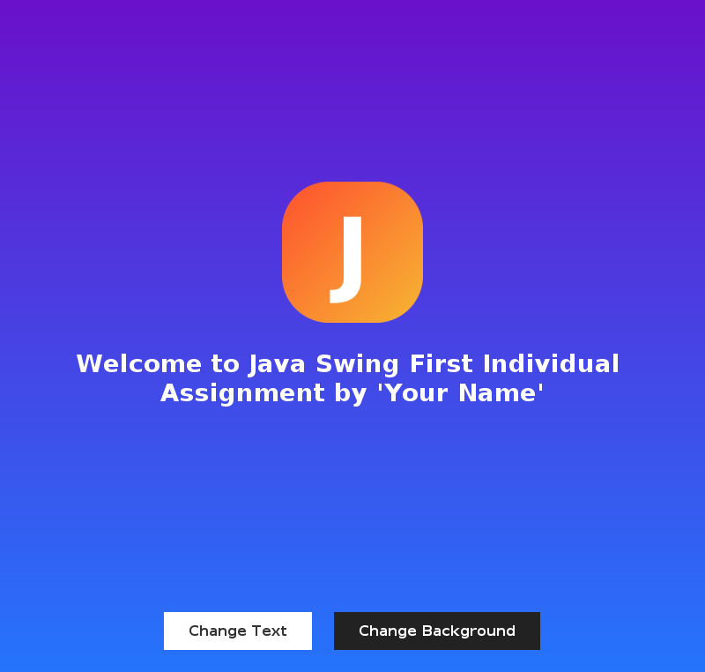
Figure 3: The running application
9. How to Run the Project
- Install JDK 11 or later and open the project folder in IntelliJ IDEA or VS Code.
- Make sure icon.png is in the same folder from which the program is started.
- Compile with “javac SwingAssignment.java” and run with “java SwingAssignment”.
The project, including the source code, icon, wireframe and README file, is available on GitHub and the lecturer was added as a collaborator.

Conclusion
The assignment shows how a simple but attractive GUI can be created with Java Swing. A JFrame, JPanel, JLabel and ImageIcon were combined, inheritance was applied through the GradientPanel class, and constructors were used to build the interface. The two buttons make the program interactive by changing the label text and the panel background. This work gave practical experience in designing a wireframe, writing GUI code and handling user events.

